MA678-Data Collection Exercise

1. Objective

I would like to compare the relationship between the frequency of drinking milk a week and some factors such as gender, whether to drink skim milk and so on.

1. Methods

I use a electronic questionnaire called ‘Questionnaire Star’ and design several questions concerning that. And my questionnaire is below.

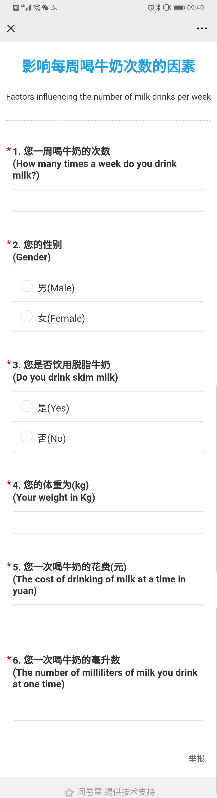

1. Interpreting original data

‘frequency’: how many times a week of drinking milk

‘gender’: 1 represents male and 2 represents female

‘skim’: whether drinking skim milk, 1 represents yes and 2 represents no

‘weight’: person’s weight in kg

‘cost’: the cost of drinking of milk at a time in yuan

‘quantity’: the number of milliliters of milk you drink at one time

1. Thoughts

The electronic questionnaire decrease the the cost (time and effort) associated with each data point because I just need send the questionnaire to different Wechat groups. Besides, anonymous questionnaire without face-to-face can avoid some inaccuracy when asking some private and embarrassing topics such as weight.